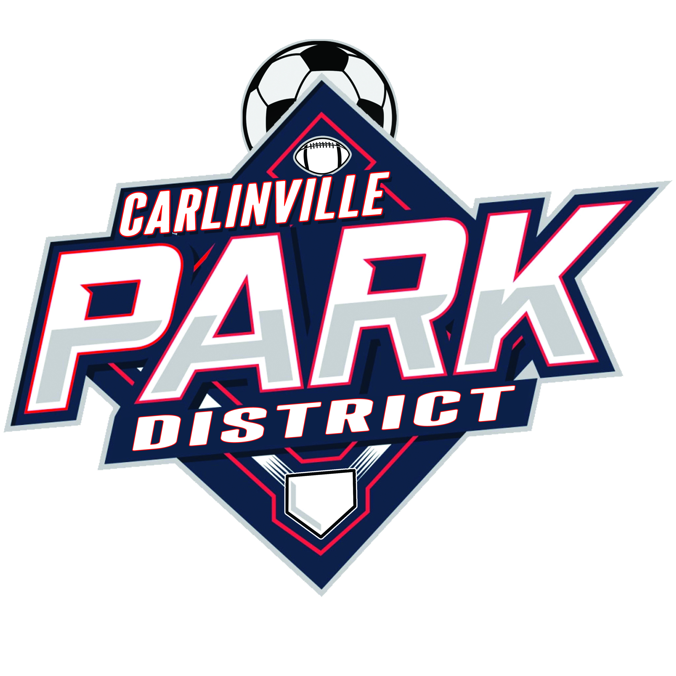

BOARD MEMBER JOB DESCRIPTION

TITLE: Board member of the Carlinville Park District

REPORTS TO: Fellow board members and constituents

PURPOSE: To serve the board as a voting member; to develop governance policies, long-range plans, procedures and regulations for the operation of the agency; to monitor finances of the agency, its programs and performance; to protect the assets of the agency; to insure the effective stewardship and management of the agency’s human, physical and financial resources.
TERM: _____ (4 year; 6 year)

EXPECTED MEETING ATTENDANCE:
- Regularly attend scheduled board meetings
- Share the responsibility for effective board leadership (which means participating in meetings and sharing opinions)
- Attend committee meetings which you serve as a member
- Attend and participate in special events and agency functions

BOARD OBLIGATIONS:
- Establish policy based on sound research and consideration of pros and cons of the issue
- Adopt policies so that the organization can run efficiently, effectively, legally and ethically
- Hire, fire, supervise, evaluate and support the executive director
- Interpret the agency’s mission, values and vision to the public
- Set strategic direction that adopts goals relating to the mission of the organization
- Secure adequate funds
- Monitor operational and capital finances
- Act as a resource, as a sounding board and as the eyes and ears for the citizens of the community, making sure that the agency is meeting their needs.
- Develop, maintain and update long-range plans
- Adopt a Code of Ethics
SPECIFIC DUTIES:
- Respect various points of view and participate in decision-making
- Be well-informed about issues and agenda items in advance of meetings
- Participate in organizational decision-making
- Represent the organization to the public and to private industry
- Educate yourself about the needs of constituents

RIGHTS OF BOARD MEMBERS:
- To be kept well informed about the strategic plan and agency operations
- To be given well written and useful background information to make decisions on the issues pertaining to the agenda
- To be part of a highly respected organization and to enjoy one another’s company and the satisfaction of meeting the park, recreation and conservation needs of all citizens

Board Member’s Signature____________________________________ Date______________

Executive Director’s Signature_________________________________ Date______________

